**Distribution table**

|  |  |  |  |  |  |  |  |  |  |  |  |  |  |  |  |  |  |  |  |  |  |  |
| --- | --- | --- | --- | --- | --- | --- | --- | --- | --- | --- | --- | --- | --- | --- | --- | --- | --- | --- | --- | --- | --- | --- |
| **Location** | **Ozone reading (ppm)** | | | | | | | | | | | | | | | | | | | | | |
| **3** | **4** | **5** | **6** | **7** | **8** | **9** | **10** | **11** | **12** | **13** | **14** | **15** | **16** | **17** | **18** | **19** | **20** | **22** | **23** | **24** | **Total** |
| **Cork** | 0 (0.0%) | 1 (5.0%) | 0 (0.0%) | 1 (5.0%) | 1 (5.0%) | 1 (5.0%) | 0 (0.0%) | 1 (5.0%) | 2 (10.0%) | 3 (15.0%) | 1 ( 5.0%) | 1 (5.0%) | 1 ( 5.0%) | 2 (10.0%) | 1 ( 5.0%) | 0 (0.0%) | 1 (5.0%) | 1 (5.0%) | 1 (5.0%) | 1 (5.0%) | 0 (0.0%) | 20 (100.0%) |
| **Shannon** | 1 (5.0%) | 0 (0.0%) | 1 (5.0%) | 0 (0.0%) | 1 (5.0%) | 1 (5.0%) | 1 (5.0%) | 1 (5.0%) | 1 ( 5.0%) | 1 ( 5.0%) | 3 (15.0%) | 1 (5.0%) | 2 (10.0%) | 0 ( 0.0%) | 3 (15.0%) | 1 (5.0%) | 0 (0.0%) | 1 (5.0%) | 0 (0.0%) | 0 (0.0%) | 1 (5.0%) | 20 (100.0%) |
| **Total** | 1 (2.5%) | 1 (2.5%) | 1 (2.5%) | 1 (2.5%) | 2 (5.0%) | 2 (5.0%) | 1 (2.5%) | 2 (5.0%) | 3 ( 7.5%) | 4 (10.0%) | 4 (10.0%) | 2 (5.0%) | 3 ( 7.5%) | 2 ( 5.0%) | 4 (10.0%) | 1 (2.5%) | 1 (2.5%) | 2 (5.0%) | 1 (2.5%) | 1 (2.5%) | 1 (2.5%) | 40 (100.0%) |

Using ctable()

**Boxplot**

Using ggplot()

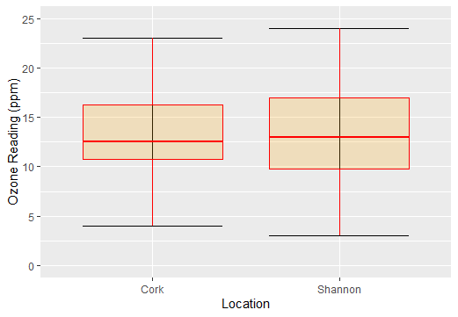

**Descriptive statistics and normality**

Using summaries ()

|  |  |  |
| --- | --- | --- |
| **Statistics** | **Location** | |
| **"Cork"** | **"Shannon"** |
| **Sample size** | "20" | "20" |
| **Mean** | "13.225" | "13.225" |
| **Standard Deviation** | "5.116527" | "5.116527" |
| **Median** | "13" | "13" |
| **1st quartile** | "10" | "10" |
| **3rd quartile** | "17" | "17" |
| **Min** | "3" | "3" |
| **Max** | "24" | "24" |